Activity 1.1.1a: Spreadsheet Practice

1) Cut and paste your first graph in your Google doc.

2) Why might a graph be more useful than looking at a table (in general)? What specifically can you see in your data that is more evident from the graph than the table?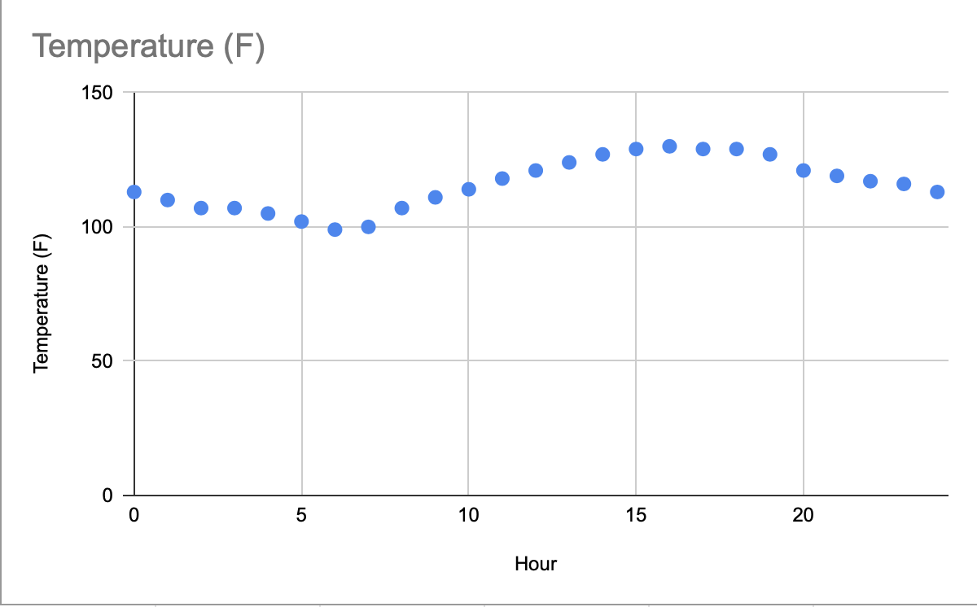

A graph might be more useful than looking at a table because it is significantly easier to see trends and patterns. The most obvious would be whether there is a positive or negative correlation between the points, but it is also easier to analyze slopes. For example, in this graph, it is now more clear to me that the temperature decreases from Hour 0 to around Hour 6 and then increases until around Hour 16. Additionally, from its shape I can see that it somewhat resembles a sinusoidal curve, which gives me a better understanding of the type of trendline I should use to analyze the data.

3)Cut and paste your second graph in your Google doc. How does changing the minimum temperature and the maximum hour improve the graph from the viewer's perspective?

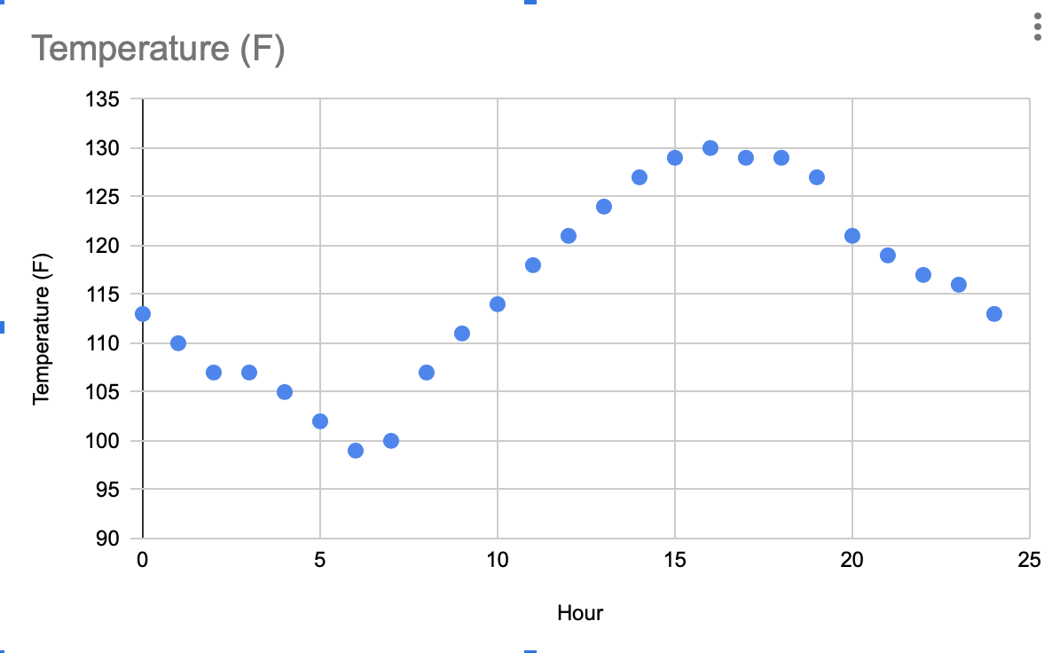

By changing the minimum temperature and the maximum hours, the graph is “zoomed” in and the viewer is able to get a closer look at the trends. It is now more apparent that the data points do not form perfect curves, but are in fact a little offset.

4) Put a border around all of your table values (Fahrenheit, Centigrade, Kelvin). Cut and paste in your Google doc.